BRIDGET MASILA

SCT221-0228/2022

21/01/2022

ASSIGNMENT TWO

**QUESTION**

**Design an algorithm to merge two sorted lists that are passed as parameters, and return one merged sorted list.**

function merge_sorted_lists(list_one, list_two):

merged_list = []

i = 0

j = 0

while i < len(list_one) and j < len(list_two):

if list_one[i] <= list_two[j]:

merged_list.append(list_one[i])

i += 1

else:

merged_list.append(list_two[j])

j += 1

while i < len(list_one):

merged_list.append(list_one[i])

i += 1

while j < len(list_two):

merged_list.append(list_two[j])

j += 1

return merged_list

**Derive a recurrence relation for this algorithm.**

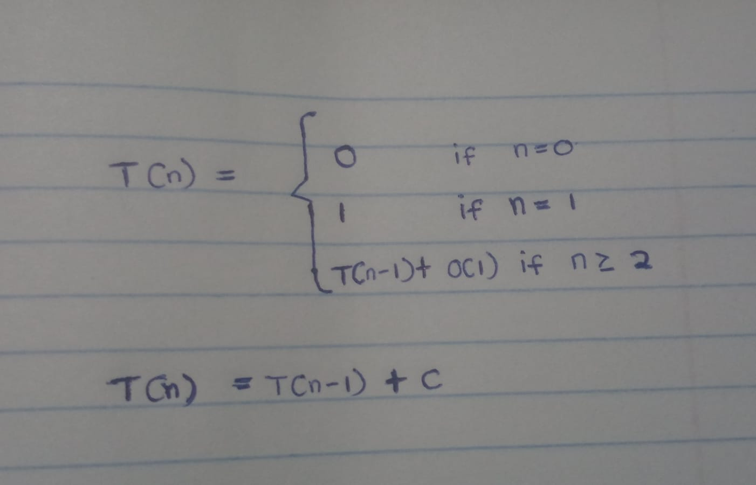

**Estimate time and space complexities for the same algorithm.**

**Time complexity**

O(n) as all elements are compared and appended exactly once.

**Space complexity**

The primary data structure used is the merged_list, which stores the combined elements of the input lists. The merged_list will contain all n elements. Hence, the space complexity is **O(n)**.